**Problem 1. Landing the slides at SlideWorld**

You have won a contract for the design of a new theme park, SlideWorld. The primary attraction

of the park is to consist of n landings, numbered 1 through n, which will be connected by a

number of slides. Each slide (i, j) connects a landing i to a landing j > i, which means that

slide (i, j) goes from landing i directly to landing j. See Figure 1 for an example of the possible

slides when n = 3.

Slideworld wants to let the customers begin their trip at any landing b and end at any other

landing e > b. Putting in all the combination slides in the park is going to break the bank. So you have been asked to determine a set of slides so that any customer can get from any landing b to any landing e > b using at most two slides. That is, it should be possible to get from any b to any e > b either by taking a direct slide (b, e) or by taking two slides (b, m) and (m, e). To be

clear, a solution of your algorithm is a set of slides.

Using divide-and-conquer, we will find a solution that uses only O(n*log n) slides while

ensuring that any customer can get from any landing b to any landing e > b using at most two

Slides.

Figure 1: An example of all possible slides when n = 3. The slides are (1, 2); (1, 3); and (2, 3).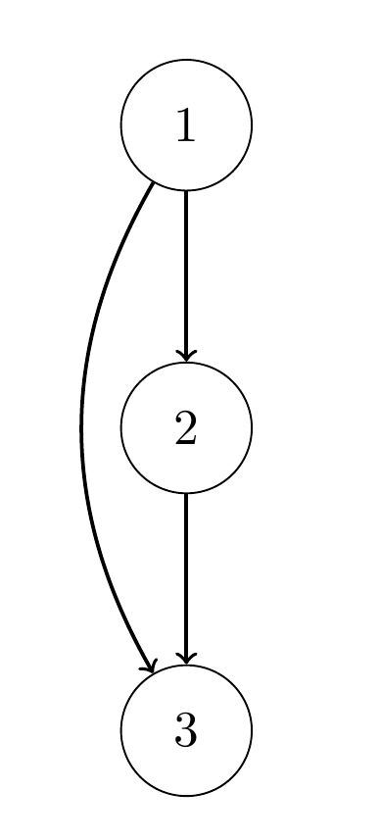

(a) For the base cases n = 1;2, design a system using at most 1 slide.

(b) For n > 2 we will use divide-and-conquer. Assume that we already put in place slides

connecting the first half landings and slides connecting the second half landings so that if i

and j both belong to the same half, we can get from i to j in at most 2 slides. Show how to

add O(n) additional slides so that if i is in the first half and j is in the second half we can

get from i to j using only two slides.

(c) Using part (b), write a divide-and-conquer algorithm that takes as input

the number of landings n and outputs the list of all the slides used by your attraction.